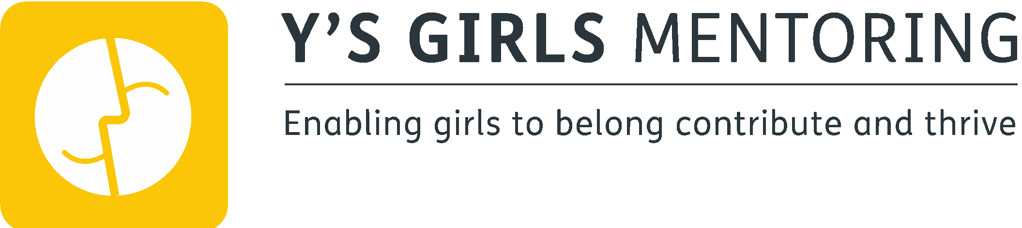
VOLUNTEER MENTOR APPLICATION FORM

Personal Details

Name
ID Number (for internal use only)
Address
Postcode
Home telephone
Mobile
Email address

Gender
Man |  | Woman |  | Intersex
Non binary |  | Prefer not to say |  | If you prefer to use your own term, please specify here

Do you hold a full driving licence? | YES | NO
Do you have access to a car? | YES | NO
*mark as appropriate

Skills / Experience

Are you currently employed? Yes / No

If yes, please state where and in which capacity

Are you currently volunteering elsewhere?
If yes, please state where and in which capacity

Are you currently a student?
If yes, please state where and what you are studying

Please give details of any past work experience and volunteering which is relevant to this role?

Please outline why you would like to become a volunteer mentor with Ys Girls mentoring?

Please give any other relevant information in support of your application
Include hobbies, interests, experiences as these can help support the matching process.

Availability
Full training will be provided. When would suit you best for volunteering/training? (Please mark availability with an x)

Day | (X) | Day | (X)
Monday Evening |  | Friday Evening
Tuesday Evening |  | Saturday
Wednesday Evening |  | Sunday
Thursday Evening

Mentors are required to meet up with a young person on a regular basis, with an initial commitment of one session per week for approximately 2 hours. Would this be possible for you?

References

Please give details of two references who we may contact in reference to your application

 | Reference 1 | Reference 2
Name
Relationship
Address
Telephone
Email

How long have you known this person?

Agreement and Signature

I declare that the information given on this form is correct and complete. False or misleading statements may be sufficient grounds for cancelling any agreements made.

Signed
Date

Due to the nature of the role, each mentor will be subject to a DBS check. If you require any more information regarding this please do not hesitate to get in touch.

Please complete this application and return it to:
Asma Iqbal
asma.iqbal@nottsymca.org

